**Recurso 70**

**IMAGEN 1**

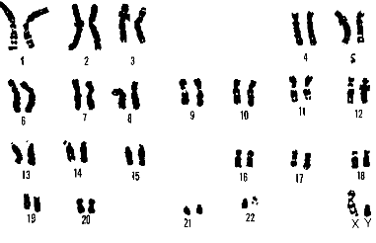 <https://upload.wikimedia.org/wikipedia/commons/a/ab/21_trisomy_-_Down_syndrome.png>

**IMAGEN 2**

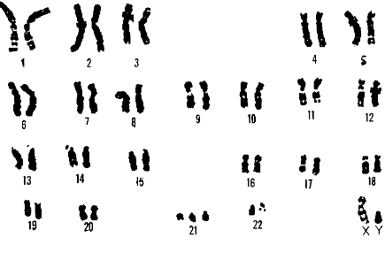 <https://upload.wikimedia.org/wikipedia/commons/a/ab/21_trisomy_-_Down_syndrome.png>

**IMAGEN 3**

|  |
| --- |
| Persona sin síndrome de Down |
|  |
| Persona con síndrome de Down |
|  |

<https://upload.wikimedia.org/wikipedia/commons/a/ab/21_trisomy_-_Down_syndrome.png>

**IMAGEN 4**

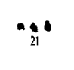

<https://upload.wikimedia.org/wikipedia/commons/a/ab/21_trisomy_-_Down_syndrome.png>

**IMAGEN 5**

 [254187073](http://www.shutterstock.com/pic-254187073/stock-photo-cute-little-girl-with-painted-hands-isolated-on-grey-background.html?src=YmQBlO1N1W__NlLi_EjHlA-1-12)